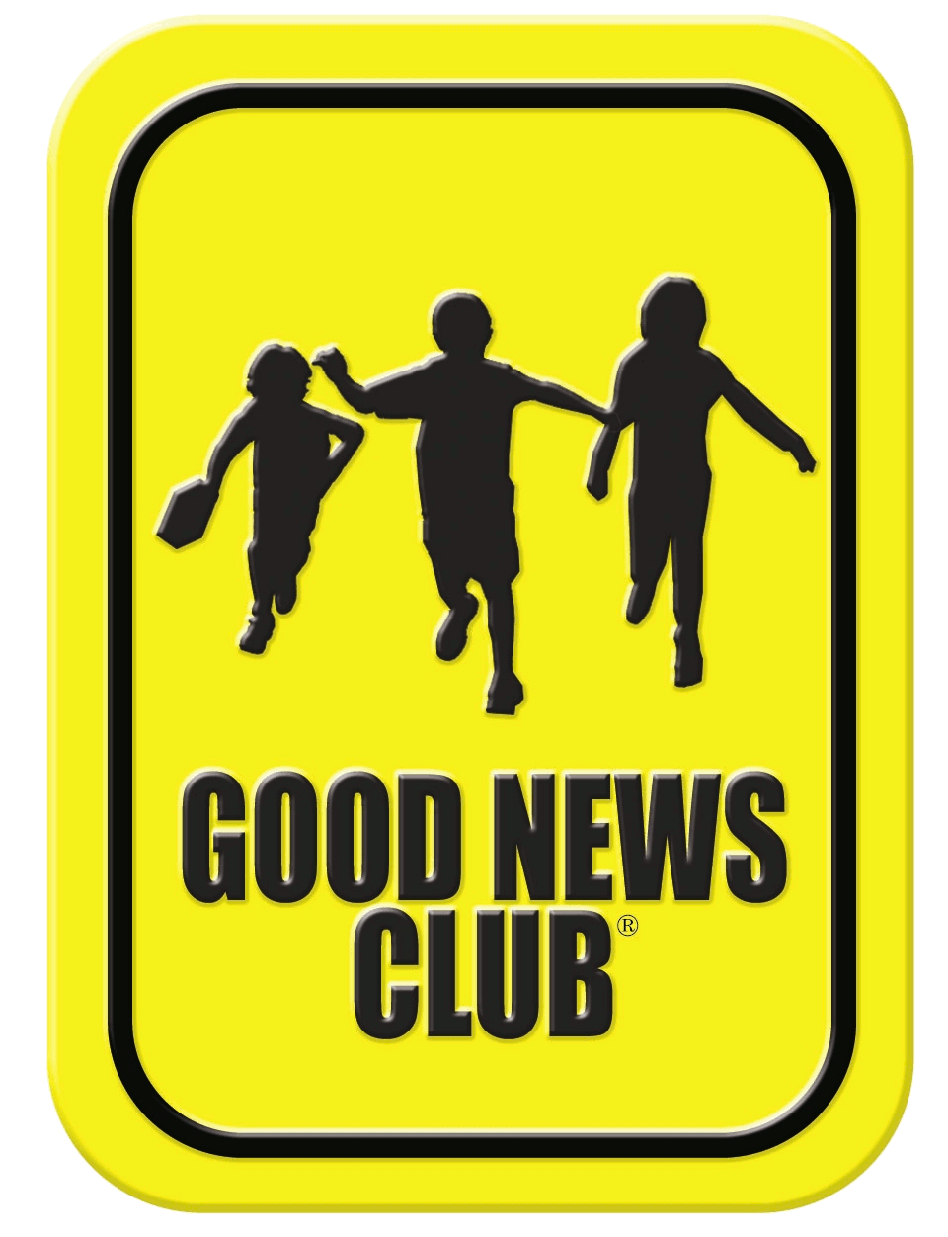
Thank you for your interest in our online Good News Club. All children are welcome with their parent’s permission. Parents and guardians are also welcome.
Online Good News Club® Registration Form

This registration is for the Good News Club hosted by: Armando Corella
Dates: Start October 7th, Wednesday and every Wednesday after
Times: 2:30 to 3:30
List children’s names and grades.
First Name: Click or tap here to enter text.  Last Name: Click or tap here to enter text.  Grade: Click or tap here to enter text. | First Name: Click or tap here to enter text.  Last Name: Click or tap here to enter text.  Grade: Click or tap here to enter text.
First Name: Click or tap here to enter text.  Last Name: Click or tap here to enter text.  Grade: Click or tap here to enter text. | First Name: Click or tap here to enter text.  Last Name: Click or tap here to enter text.  Grade: Click or tap here to enter text.

Name of School: Stanton Elementary
County: Los Angeles (Glendora District) State: California

Family email address: Click or tap here to enter text.

Family phone number: Click or tap here to enter text.

☐ My children, listed on this form, have permission to attend the CEF online Good News Club.

Parent/guardian signature: Click or tap here to enter text. Date: Click or tap to enter a date.
(NOTE: On electronic forms, your typed signature has the same effect as your written signature.)
When we receive your completed registration form, we will send information on how to access the online Good News Club. For your child’s safety, only children with permission may attend, this includes the children under your supervision in this household have permission to attend the CEF online Good News Club. Also, teachers in our clubs have been screened according to the Child Protection Policy of Child Evangelism Fellowship.

Children may invite friends by using the invitation below/attached/or at this link.

Return completed form to school email address and cc to: acorella1@msn.com
Please feel free to contact us if you have any questions. Armando Corella at acorella1@msn.com

Good News Club is a ministry of Child Evangelism Fellowship®.

Photography and Video Release (Not required for club attendance)
Child Evangelism Fellowship® may, from time to time, document the activities of the ministry with photos or videos. I hereby assign and grant to Child Evangelism Fellowship Inc., its subsidiaries and successors, and assign the unqualified right to the ownership, use and proceeds of all photographs or video of me or my minor child, without reservation or limitation, including use of photographs or video of me or my minor child for, but not limited to, advertising, educational and promotional purposes.
Parent/guardian signature: Click or tap here to enter text. Date: Click or tap to enter a date.
(NOTE: On electronic forms, your typed signature has the same effect as your written signature.)
GNC: 2020/21

